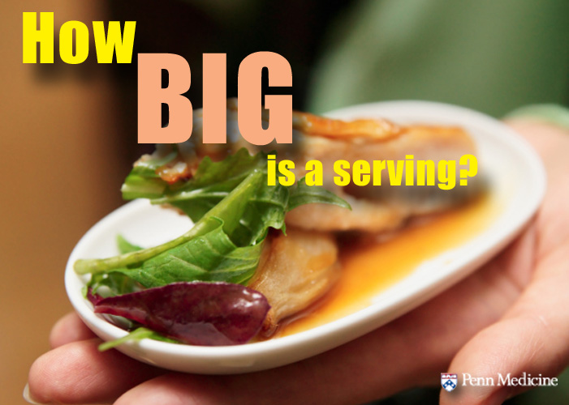**How Big is a Serving of Food?**

The good news is that it is easy to measure a serving of food. Sticking to that recommended serving size is another story, but if you are committed to getting back on track to health, measuring your food – even casually – is a must.   
  
You don’t need a scale or measuring cups to get an idea of how much is in a serving.

**Serving Size Guide**

Print out this guide and use it in your kitchen or at the dinner table until you get a feel for what a serving size it. Also, if you haven’t measured your portions in a while, it might be a good refresher to measure serving sizes for a while until you get back on track.

* 3 oz. of meat = A deck of cards
* 3 oz. of fish = A checkbook
* 1 ½ oz. of cheese = 3 dice
* 2 tbsp. peanut butter = A ping pong ball
* 1 medium-sized fruit = A baseball
* 1 cup of cooked vegetables = A baseball
* 1 medium potato = A computer mouse
* 1 cup pasta = A baseball
* 1 bagel = A hockey puck
* ½ cup of ice cream = A light bulb
* 1 tbsp. butter or oil = A poker chip

Source: <http://penn-bariatric-weight-loss-surgery.blogspot.com/2013/01/how-big-is-a-serving.html>